WEIGHT AND BALANCE REPORT
(Example document for LSA applicants – v1 of 08.03.16)

Date of issue: DD/MM/YYYY
Document reference: ABCD-WB-08-00

 | Approval data
 | Prepared by | Verified by | Approved by
Name, sign.
Function | Design Engineer |  | Design Manager

Record of Revision
Rev. # | Issue date | Description of change
0 |  | Initial issue

Introduction
This document defines the weight and balance envelope of the ABCD aircraft according to the applicable certification specification CS-LSA. The requirements are referenced in the compliance checklist of the certification programme ABCD-CP-00.
The permissible centre of gravity range is dictated by the aerodynamic design requirements for the airplane. Then the centre of gravity locations corresponding to the critical weights are calculated.
All units used are metric (SI units) except for airspeeds (CAS) given in knots if not stated otherwise.
Note: The values defined within this document should be used for the placards, markings, aeroplane flight manual (limitations), load calculations and need to be verified by testing.
NOTICE
This document is to provide an example of a weight and balance document for an aircraft type certificate application in accordance with CS-LSA. The document can be used even if the applicant does not own a DOA. It does not substitute, in any of its parts, the prescriptions of Part-21 and its amendments.
This document is intended to assist applicants in applying for an LSA RTC/TC and therefore demonstrating compliance of the design to the requirements.
The document should not be read as a template and it should not be used as a form to fill. The content shall be checked for appropriateness and changed accordingly by the applicant.
The required information can be presented entirely in this document, or in additional documents appropriately identified and referred to.
Comments and notes to the user are provided throughout the document with “blue highlighted and italic text”.
IMPORTANT: All the statements and/or conclusions provided in this guideline can be considered realistic and have a reasonable technical basis but the designer is solely responsible of each of the statements that he/she will provide

Contents
0. Introduction 2
1. References 4
2. List of Abbreviations 4
3. Requirements 5
4. Reference for centre of gravity values 5
5. Mass items 6
6. Aircraft weights 6
6.1 Basic empty weight W_{BEW} 6
6.2 Basic empty weight (366 kg) vs maximum empty weight W_{MEW} (400kg) 6
6.3 Minimum flying weight W_{min} (421kg) 7
6.4 Minimum full fuel flying weight W_{minFF} (495kg) 7
6.5 Maximum zero wing fuel weight W_{ZWF} (600kg) 7
6.6 Maximum take-off weight W_{MTOW} (600kg) 7
6.7 Loading cases 7
7. Centre of gravity location 8
7.1 Flight limits 8
7.2 Limitations on ground 8
7.3 Centre of gravity envelope 8
7.4 Expanded centre of gravity envelope for certification 9
8. Compliance statements 11

References

[1] | “ABCD-GD-01-00 Aeroplane General Description,” EASA.
[2] | “ASTM F2245-12d,” ASTM.
[3] | “ABCD-FTR-01-00 Flight Test Report,” EASA.
[4] | “ABCD-FL-57-00 Wing Load Calculation,” EASA.
[5] | “CS-LSA Certification Specifications and Acceptable Means of Compliance, Amnd.1 29.Jul.2013,” EASA, 2013.

List of Abbreviations
CG centre of gravity
MAC mean aerodynamic chord from design description ( [1])
g gravity acceleration equals 9.81 m/s² [m/s²]
$V_{H}$ maximum level flying speed with maximum continuous power [kts]
$W_{EW}$ aeroplane empty weight [kg]
$W_{BEW}$ aeroplane basic empty weight including unusable fuel [kg]
$W_{MTOW}$ aeroplane maximum take-off weight [kg]
$W_{min}$ aeroplane minimum flying weight [kg]
$W_{minFF}$ aeroplane minimum flying weight with full fuel [kg]
$W_{U}$ minimum useful load [kg]
$W_{ZWF}$ aeroplane maximum zero wing fuel weight [kg]
W_{E} maximum empty weight [kg]

Requirements
This document covers the following certification specifications requirements:
Requirement  CS-LSA.15, 29th July 2013 amendment 1  (ASTM F2245-12d) | Subject of requirement | Referenced chapter
3.1 | Definitions: | –
3.1.2 | maximum empty weight, W_{E} – largest empty weight of the airplane, including all operational equipment that is installed in the airplane: weight of the airframe, powerplant, required equipment, optional and specific equipment, fixed ballast, full engine coolant and oil, hydraulic fluid, and the unusable fuel. Hence, the maximum empty weight equals maximum takeoff weight minus minimum useful load: W_{E} = W − W_{U}. | 6.2
3.1.3 | minimum useful load, W_{U} – where W_{U} = W − W_{E}. | 6.2
4.2 | Load Distribution Limits: | –
4.2.1  4.2.1.1  4.2.1.2 | The minimum useful load, W_{U}, shall be equal to or greater than the sum of: An occupant weight of 845 N (190 lb) for each occupant seat in aircraft, plus the weight of consumable substances, such as fuel, as required for a 1-h flight at V_{H}. Consumption rates must be based on test results for the specific application. | 6.2
4.2.2 | The minimum flying weight shall be determined. | 6.3
4.2.3 | Empty CG, most forward, and most rearward CG shall be determined. | 7.1  7.2
5.2 | Flight Loads:
5.2.1.3 | Maximum Zero Wing Fuel Weight, W_{ZWF} – The maximum allowable weight of the airplane without any fuel in the wing tank(s) must be established if it is less than maximum design weight, W. | 6.5
Table 1 – Requirements

Reference for centre of gravity values
Datum plane: leading edge at wing mean aerodynamic chord

Mass items
The single weight items with their corresponding centre of gravity locations are listed below. The data contained herein is used to establish aeroplane loading limits:
Weight items
Item | Includes | Weight |  | Centre of gravity | Determined by
Empty aircraft (W_{EW}) | equipment and all necessary fluids (oil, coolant) except fuel | 360kg |  | 0.402 m | Weighting
Fuel | unusable fuel | min 6kg | max 80kg | 0.300 m | Design
Pilot and single passenger |  | min 55kg | max 234kg  (117kg for each seat)* | 0 m | Design
Baggage |  | Min 0kg | Max 20kg | 0.500 m | Design
Table 2 – Mass items
(Note: In this document the weight of the empty aircraft is assumed to be determined through direct weighing. Such information might be needed during early phases of the design, when no prototype is available. In this case the weight of the empty aircraft should be determined through estimation. It is important in this case to have a breakdown of the main items in terms of weight and locations, so that the weight can be kept under control and avoid situations where the assumed envelope cannot be achieved.)

Aircraft weights
The following design weights have been identified since:
- either they are clearly required by the CS-LSA requirements, or
- they impose critical loads or flight characteristics.

Basic empty weight W_{BEW}
The basic empty weight needs to be determined to identify its centre of gravity according to requirement 4.2.3 [2] as empty CG. All load conditions determined within this document are based on the basic empty weight of the aircraft. It includes empty weight of the aircraft and the unusable amount of fuel. Basic empty weight has been determined to W_{BEW} = 366 kg.
Note: The basic empty weight must include all equipment for the operation intended including optional avionics packages – for example.

Basic empty weight (366 kg) vs maximum empty weight W_{MEW} (400kg)
According to 4.2.1 of [2], the minimum useful load $W_{U}$ should be 200kg consisting of
- 172Kg = both seats occupied with persons of 86kg each (4.2.1.1 [2])
- 28kg = fuel for 1 hour flight at $V_{H}$ as determined by [3] (4.2.1.2 [2])
According to 3.1.2 [2] the maximum empty weight of the aeroplane shall be equal to:
$W_{MEW}=W_{MTOW}-W_{U}=600-200=400kg$.
The aeroplane complies with its Basic empty weight including unusable fuel:
$W_{BEW+UF}=366kg<W_{E}=400kg$.

Minimum flying weight W_{min} (421kg)
The minimum flying weight needs to be determined by requirement 4.2.2 [2] and is a design load case leading to highest load factors during gust penetration. It assumes only a pilot of weight of 55 kg.

Minimum full fuel flying weight W_{minFF} (495kg)
The minimum flying weight with full fuel is a design load case imposing highest load factors on the fuel tank. This is critical for the fuel tank design and it can be critical also for the wing structure since in this scenario the highest inertia load on the fuel tank introduces torsion about the shear centre in the same direction of the wing aerodynamic load of the wing (the CG of the fuel is forward to the shear centre which is forward to the wing centre of pressure).

Maximum zero wing fuel weight W_{ZWF} (600kg)
The maximum zero wing fuel weight needs to be determined by requirement 5.2.1.3 [2] and is a design load case for the wing loads due to lowest inertia discharge of the wing structure. In this aeroplane this weight equals the Maximum Take-off weight.

Maximum take-off weight W_{MTOW} (600kg)
The total aircraft weight must not exceed 600kg regardless whether the aircraft is on ground or in flight. The gross weight of the aeroplane shall not exceed W_{MTOW} = 600kg. The maximum landing weight equals the maximum take-off weight.

Loading cases
The following loading conditions have been established to identify the critical cases.
Aircraft weights
 |  | Includes |  | Centre of gravity |  | Determined by | Requirement
Basic Empty weight | $$W_{BEW}$$ | all necessary fluids (oil, coolant) and unusable fuel | 366kg | 0.402 m |  | Weighting | 4.2.3 [2]
Minimum flying weight | $$W_{min}$$ | min pilot and unusable fuel | 421kg | 0.349 m |  | Design | 4.2.2 [2]
Minimum flying weight with full fuel | $$W_{minFF}$$ | min pilot and full fuel | 495kg | 0.342 m |  | Design | Load calculation [4]
Maximum zero wing-fuel weight | $$W_{ZWF}$$ | full useful load of $W_{load}$ and $W_{bag}$ | 600kg | fwd 0.272 m | aft 0.278 m | Design | 5.2.1.3 [2]
Maximum take-off weight | $$W_{MTOW}$$ | combination of fuel and passenger load | 600kg | fwd 0.265 m | aft 0.315 m | Design | CS-LSA.5
Table 3 – Loading cases for standard configuration

Centre of gravity location
The maximum permissible centre of gravity locations are defined within this chapter.

Flight limits
The maximum permissible centre of gravity range during flight with respect to datum plane is
- most forward 0.25m (required by [2] 4.2.3)
- most rearward 0.39m (required by [2] 4.2.3)

Limitations on ground
The most rearward centre of gravity with the plane on ground must not exceed (with respect to datum plane) 0.46m to prevent the aircraft from flipping on the tail although not more than 0.41m might be reached with the most critical loading configuration.

Centre of gravity envelope
The following table of load cases defines the limits for the certified envelope of centre of gravity locations and the position of load cases of 6.7 within the envelope.
 | Condition | Pax (CG=0.00m) |  | Fuel (CG=0.30m) |  | Baggage (CG=0.50m) |  | Aircraft weight | Aircraft CG (MAC)
 |  |  | kg |  | kg |  | kg | kg | m
CG envelope limits for flight | $$W_{MTOW,aft}$$ |  | 140 | full | 80 | max | 20 | 600 | 0.309
 | $$W_{MTOW,fwd}$$ | max | 234 |  |  | empty | 0 | 600 | 0.256
 | $$W_{min,aft}$$ | min | 55 |  |  | max | 20 | 441 | 0.364
 | $$W_{MTOW,fwdmax}$$ | max | 234 |  |  | empty | 0 | 600 | 0.256
 | $$W_{min}$$ | min | 55 |  |  | empty | 0 | 421 | 0.353
Loading conditions in flight | $$W_{minFF}$$ | min | 55 | full | 80 | empty | 0 | 495 | 0.345
 | $$W_{ZWF,aft}$$ |  | 214 |  |  | max | 20 | 600 | 0.275
 | $$W_{ZWF,fwd}$$ | max | 234 |  |  | empty | 0 | 600 | 0.256
 | $$W_{minFFbag}$$ | min | 55 | full | 80 | max | 20 | 515 | 0.355
Loading conditions on ground | $$W_{BEW}$$ | empty | 0 |  |  | empty | 0 | 366 | 0.402
 | $$W_{⁡aftmax}$$ | empty | 0 |  |  | max | 20 | 386 | 0.412
Table 4 – Load cases on centre of gravity envelope for standard configuration

The centre of gravity envelope covers all valid loading cases.
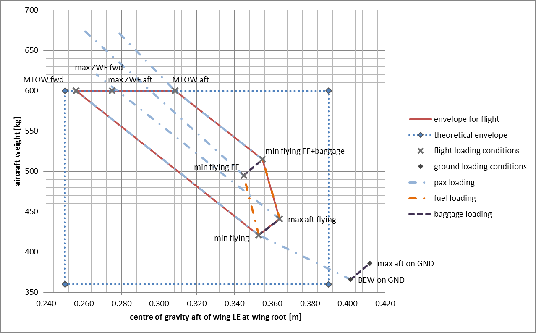
Figure 1 – Centre of gravity envelope for standard configuration

Expanded centre of gravity envelope for certification
To cover alterations to the aeroplane where need might arise or after certification the aeroplane will be tested and certified against an extended envelope. Additional weights will be added during testing at their corresponding locations to establish the desired loading cases.
Ballast weights
Item | Attached to | Weight | Centre of gravity
Front ballast weight | Forward of firewall at fuselage | max 35 kg | -1.000 m
Rear ballast weight | Horizontal stabiliser attachment at fuselage | max 25 kg | 2.800 m
Table 5 – Weights required to achieve expanded envelope for certification

The expanded centre of gravity envelope is defined by the load cases below using ballast weights at their corresponding locations.
Expanded centre of gravity envelope load cases
 | condition | Pax  (CG= 0.00m) |  | Fuel  (CG= 0.30m) |  | Baggage  (CG= 0.50m) |  | Front ballast weight  (CG= -1.00m) | Rear ballast weight (CG= 2.80m) | aircraft weight | aircraft CG  (at MAC)
 |  |  | kg |  | kg |  | kg | kg | kg | kg | m
Design W&B envelope | $$W_{MTOW,aft}$$ |  | 122 | full | 80 | max | 20 | 0 | 18 | 600 | 0.390
 | $$W_{MTOW,fwd}$$ |  | 137 | full | 80 | empty | 0 | 23 | 0 | 600 | 0.250
 | $$W_{ZWF,fwd}$$ |  | 230 |  |  | empty | 0 | 4 | 0 | 600 | 0.250
 | $$W_{ZWF,aft}$$ |  | 189 |  |  | max | 20 | 0 | 25 | 600 | 0.390
 | $$W_{min,aft}$$ | min | 55 |  |  | empty | 0 | 0 | 7 | 428 | 0.390
 | $$W_{min,fwd}$$ | min | 55 |  |  | empty | 0 | 35 | 0 | 456 | 0.250
 | $$W_{minFF}$$ | min | 55 | full | 80 | empty | 0 | 0 | 0 | 495 | 0.345
Table 6 – Load cases on expanded centre of gravity envelope for certification
Note: The values above are preliminary assumptions. Ballast weights need to be checked to be in accordance with airframe strength limitations and their impact on the flight characteristics in terms of inertia before test flights. This might require narrowing the centre of gravity envelope.
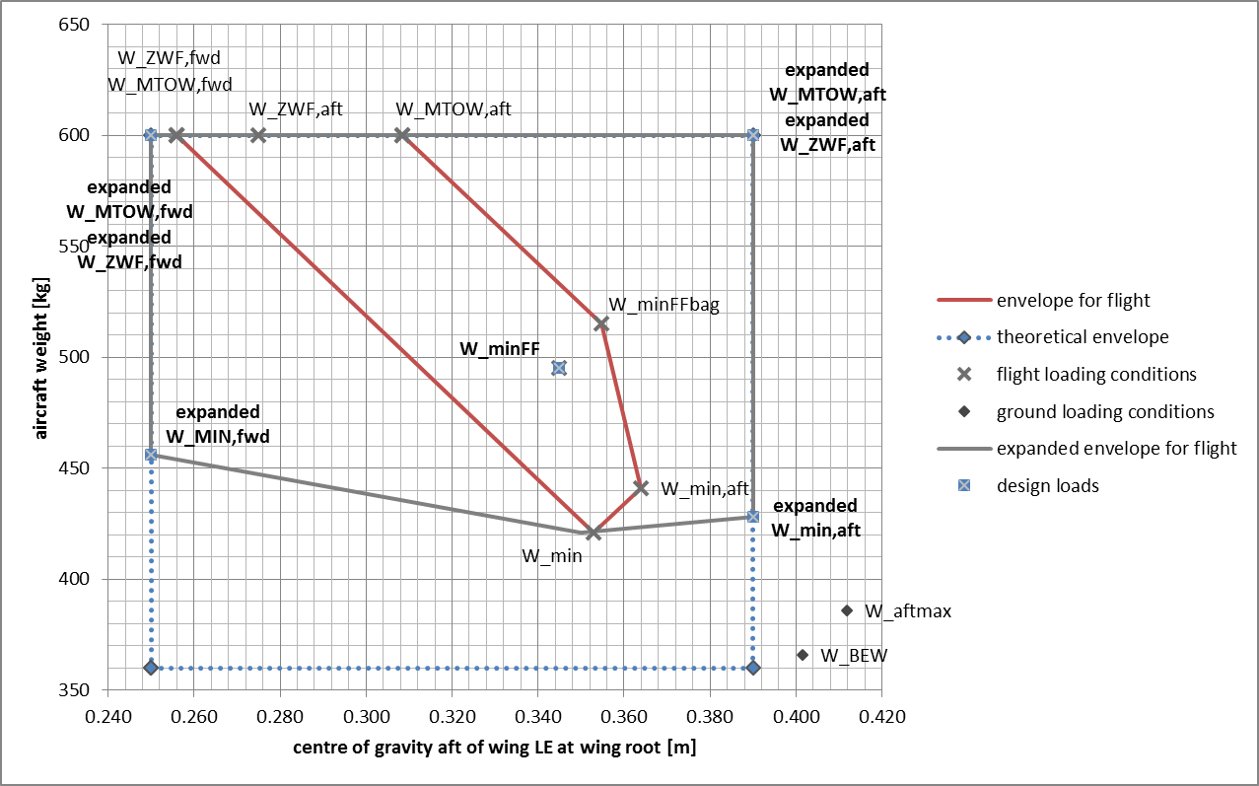
Figure 2 – Expanded centre of gravity envelope for certification

Compliance statements
Compliance statements are shown below:
Requirement reference | Subject
CS-LSA F2245-12d  3.1.2 | 3.1.2 maximum empty weight, W_{E} (N) – largest empty weight of the airplane, including all operational equipment that is installed in the airplane: weight of the airframe, powerplant, required equipment, optional and specific equipment, fixed ballast, full engine coolant and oil, hydraulic fluid, and the unusable fuel. Hence, the maximum empty weight equals maximum takeoff weight minus minimum useful load: W_{E} = W − W_{U}.
Statement of compliance | Fulfilled, maximum empty weight is less than basic empty weight plus unusable amount of fuel. See chapter 6.2.

Requirement reference | Subject
CS-LSA F2245-12d  3.1.3 | 3.1.3 minimum useful load, W_{U} (N) – where W_{U} = W − W_{E}.
Statement of compliance | The minimum useful load has been calculated (200kg). Compliance has been shpow in chapter 6.2.

Requirement reference | Subject
CS-LSA F2245-12d  4.2.1  4.2.1.1  4.2.1.2 | 4.2.1 The minimum useful load, W_{U}, shall be equal to or greater than the sum of: 4.2.1.1 An occupant weight of 845 N (190 lb) for each occupant seat in aircraft, plus 4.2.1.2 The weight of consumable substances, such as fuel, as required for a 1-h flight at V_{H}. Consumption rates must be based on test results for the specific application.
Statement of compliance | Calculated according to definition. See chapter 6.2.

Requirement reference | Subject
CS-LSA F2245-12d  4.2.2 | 4.2.2 The minimum flying weight shall be determined.
Statement of compliance | Determined with single pilot of 55kg and unusable amount of fuel. See chapter 6.3.

Requirement reference | Subject
CS-LSA F2245-12d  4.2.3 | 4.2.3 Empty CG, most forward, and most rearward CG shall be determined.
Statement of compliance | Determined for flight and on ground. See chapter 7.1 and 7.2.

Requirement reference | Subject
CS-LSA F2245-12d  5.2.1.3 | 5.2.1.3 Maximum Zero Wing Fuel Weight, W_{ZWF} – The maximum allowable weight of the airplane without any fuel in the wing tank(s) must be established if it is less than maximum design weight, W.
Statement of compliance | Maximum zero wing fuel weight is equal to maximum take-off weight. See chapter 6.5.

